# Java Web Development Basics

# Java EE Workshop – Servlets & JSP

# MeTube v.3

**MeTube** is like YouTube, “ama ne bash” like an old Bulgarian Sage once said. You have been tasked to implement this application for literally no money, by the richest man on earth. There are several requirements you must follow in the implementation.

In this part you will extend the MeTube application by adding **Admin** functionality.

## Database Requirements

Extend the **Database** of the application by adding:

### UserRole

* Can be either "User" or "Admin".

### TubeStatus

* Can be either "Pending", "Approved" or "Declined".

Add a UserRole property to the User entity and a TubeStatus property to the Tube entity.

## Templates

**Admins** have access to an **additional button** on their **navbar**.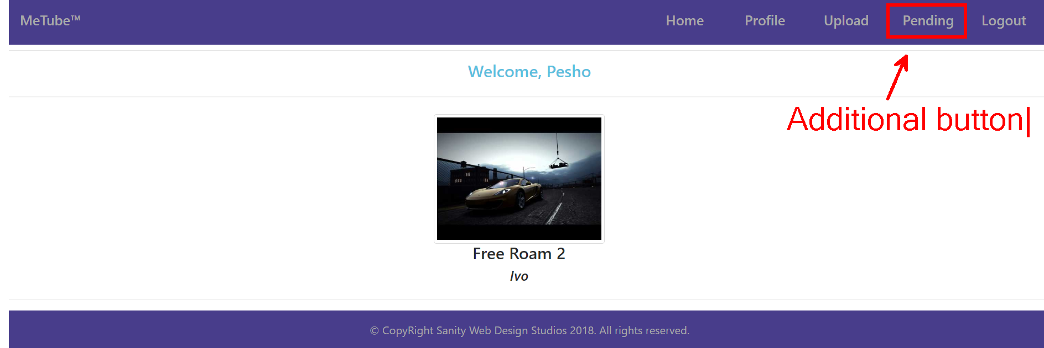

That button redirects to the Pending Tubes page (url = "/admin/tube/pending”)

It should look like this:

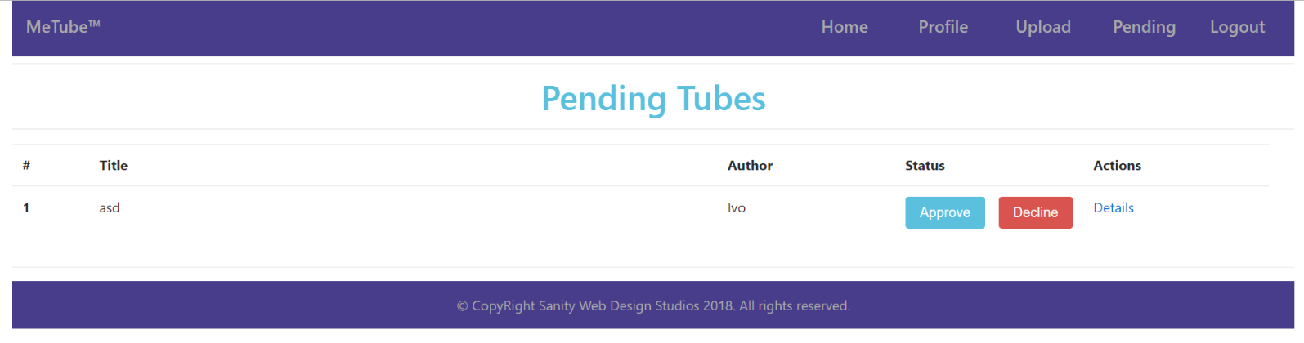

**NOTE**: All the templates have been given to you as .html files. You need to make .jsp files from them.

**NOTE**: The templates do **NOT** **require** **additional** **CSS** for you to write. Only **bootstrap** and the **given css** are enough.

## Functional Requirements

The **first registered User** in the database should be given role – "Admin". All others should be regular Users.

Tubes are created with status – "Pending" by default. Tubes with status Pending can only be seen by an Admin on the **Pending Tubes** page or by a User on their **Profile page**. An Admin can **Approve** or **Decline** Tubes from the **Pending Tubes** page.

Approved Tubes are visualized on the **Index page**.

Declined Tubes can only be accessed by the **Uploader**’s **Profile Page**.

## Security Requirements

The Security Requirements are mainly access requirements. Configurations about which users can access specific functionalities and pages.

* Guest (not logged in) users can access Index page.
* Guest (not logged in) users can access Login page.
* Guest (not logged in) users can access Register page.
* Users (logged in) can access Home page.
* Users (logged in) can access Profile page.
* Users (logged in) can access Upload functionality.
* Users (logged in) can access Details functionality.
* Users (logged in) can access Logout functionality.
* Admins (logged in, with role – "Admin") can access the Pending Tubes functionality.
* Admins (logged in, with role – "Admin") can access the Approve Tubes functionality.
* Admins (logged in, with role – "Admin") can access the Decline Tubes functionality.